Radioactive isotopes have a variety of applications. Generally, however, they are useful either because we can detect their radioactivity or we can use the energy they release.
Radioactive isotopes are effective tracers because their radioactivity is easy to detect. A tracer is a substance that can be used to follow the pathway of that substance through some structure. For instance, leaks in underground water pipes can be discovered by running some tritium-containing water through the pipes and then using a Geiger counter to locate any radioactive tritium subsequently present in the ground around the pipes. (Recall that tritium, ³H, is a radioactive isotope of hydrogen.)
Tracers can also be used to follow the steps of a complex chemical reaction. After incorporating radioactive atoms into reactant molecules, scientists can track where the atoms go by following their radioactivity. One excellent example of this is the use of radioactive carbon-14 to determine the steps involved in the photosynthesis in plants. We know these steps because researchers followed the progress of the radioactive carbon-14 throughout the process.
Radioactive isotopes are useful for establishing the ages of various objects. The half-life of radioactive isotopes is unaffected by any environmental factors, so the isotope acts like an internal clock. For example, if a rock is analyzed and is found to contain a certain amount of uranium-235 and a certain amount of its daughter isotope, we can conclude that a certain fraction of the original uranium-235 has radioactively decayed. If half of the uranium has decayed, then the rock has an age of one half-life of uranium-235, or about 4.5 × 10⁹ y. Many analyses like this, using a wide variety of isotopes, have indicated that the age of Earth itself is over 4 × 10⁹ y. In another interesting example of radioactive dating, ³H dating has been used to verify the stated vintages of some old fine wines.
Carbon-14 (half-life is 5,370 y) is particularly useful in determining the age of once-living artifacts (e.g., animal or plant matter). A tiny amount of carbon-14 is produced naturally in the upper reaches of the atmosphere, and living things incorporate some of it into their tissues, building up to a constant, although very low, level. Once a living thing dies, however, it no longer acquires carbon-14, and as time passes, the carbon-14 that was in the tissues decays. If a once-living artifact is discovered and analyzed many years after its death, with the remaining carbon-14 compared to the known constant level, an approximate age of the artifact can be determined. Using such methods, scientists determined that the age of the Shroud of Turin (made of linen, which comes from the flax plant, and purported by some to be the burial cloth of Jesus Christ; Figure 11.3 "Shroud of Turin") is about 600–700 y, not 2,000 y as claimed by some. Scientists were also able to use radiocarbon dating to show that the age of a mummified body found in the ice of the Alps was 5,300 y.
In 1989, several groups of scientists used carbon-14 dating to demonstrate that the age of the Shroud of Turin was only 600–700 y. Many people still cling to a different notion, despite the scientific evidence.
The radiation emitted by some radioactive substances can be used to kill microorganisms on a variety of foodstuffs, which extends the shelf life of these products. Produce such as tomatoes, mushrooms, sprouts, and berries are irradiated with the emissions from cobalt-60 or cesium-137. This exposure kills a lot of the bacteria that cause spoilage, so the produce stays fresh longer. Eggs and some meat, such as beef, pork, and poultry, can also be irradiated. Contrary to the belief of some people, irradiation of food does not make the food itself radioactive.

Figure 11.3 Shroud of Turin
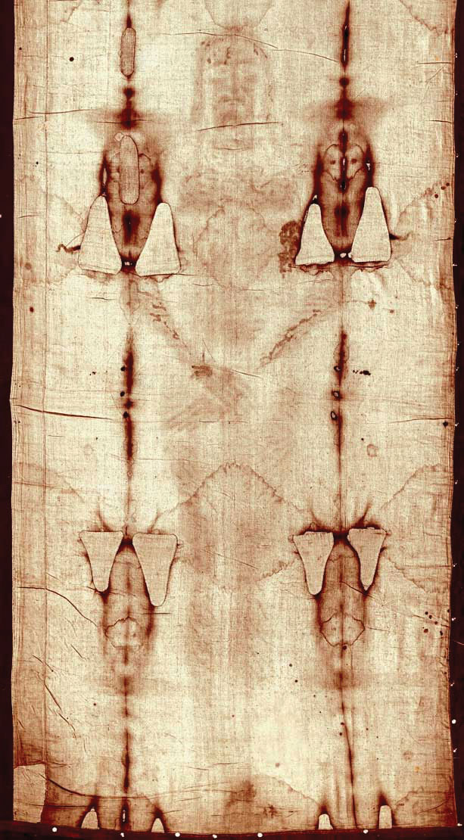
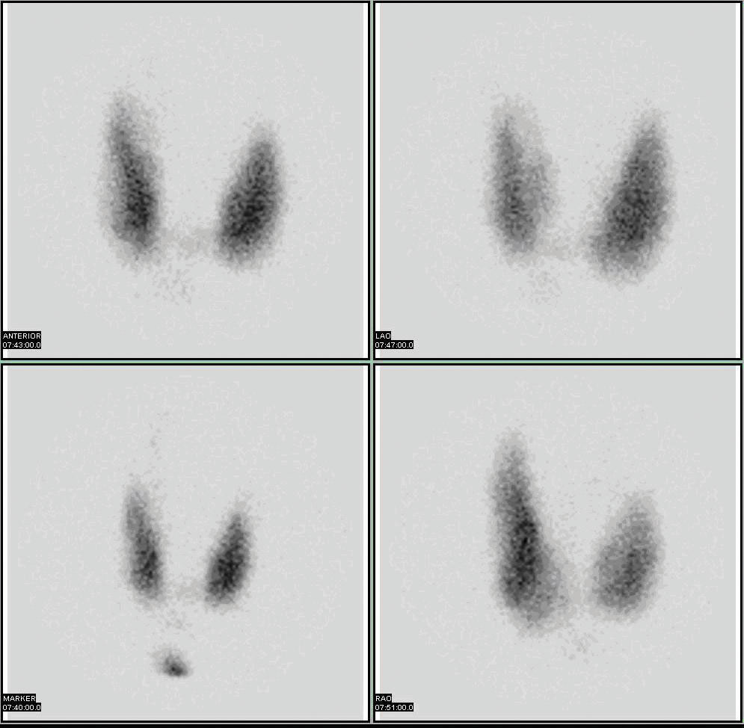
Figure 11.4 Medical Diagnostics
Radioactive iodine can be used to image the thyroid gland for diagnostic purposes.
Source: Scan courtesy of Myo Han, http://en.wikipedia.org/wiki/File:Thyroid_scan.jpg.
Very little radioactive material is needed in these diagnostic techniques because the radiation emitted is so easy to detect. However, therapeutic applications usually require much larger doses because their purpose is to preferentially kill diseased tissues. For example, if a thyroid tumor is detected, a much larger infusion (thousands of rem, as opposed to a diagnostic dose of less then 40 rem) of iodine-131 could help destroy the tumor cells. Similarly, radioactive strontium is used to not only detect but also ease the pain of bone cancers. Table 11.5 "Some Radioactive Isotopes That Have Medical Applications" lists several radioactive isotopes and their medical uses.
Table 11.5 Some Radioactive Isotopes That Have Medical Applications
Isotope | Use
³²P | cancer detection and treatment, especially in eyes and skin
⁵⁹Fe | anemia diagnosis
⁶⁰Co | gamma ray irradiation of tumors
^{99m}Tc | brain, thyroid, liver, bone marrow, lung, heart, and intestinal scanning; blood volume determination
¹³¹I | diagnosis and treatment of thyroid function
¹³³Xe | lung imaging
¹⁹⁸Au | liver disease diagnosis
In addition to the direct application of radioactive isotopes to diseased tissue, the gamma ray emissions of some isotopes can be directed toward the tissue to be destroyed. Cobalt-60 is a useful isotope for this kind of procedure.
Some atoms have unstable nuclei that emit particles and high-energy electromagnetic radiation to form new elements that are more stable. This emission of particles and electromagnetic radiation is called radioactivity. There are three main types of spontaneous radioactive emission: alpha particles, which are equivalent to helium nuclei; beta particles, which are electrons; and gamma radiation, which is high-energy electromagnetic radiation. Another type of radioactive process is spontaneous fission, in which large nuclei spontaneously break apart into smaller nuclei and, often, neutrons. In all forms of radioactivity, new elements are formed from the radioactive reactants.
Radioactive isotopes decay at different rates. The rate of an isotope’s decay is expressed as a half-life, which is the amount of time required for half of the original material to decay. The length of its half-life is a characteristic of the particular isotope and can range from less than microseconds to billions of years.
Amounts of radioactivity are measured in several different ways. A becquerel is equal to one radioactive decay per second. A curie represents 3.7 × 10¹⁰ decays per second. Other units describe the amount of energy absorbed by body tissues. One rad is equivalent to 0.01 joule of energy absorbed per gram of tissue. Different tissues react differently to different types of radioactivity. The rem unit takes into account not only the energy absorbed by the tissues, but also includes a numerical multiplication factor to account for the type of radioactivity and the type of tissue. The average annual radiation exposure of a person is less than 360 millirem, over 80% of which is from natural sources. Radioactivity can be detected using photographic film or other devices such as Geiger counters.
Radioactive isotopes have many useful applications. They can be used as tracers to follow the journey of a substance through a system, like an underground waterway or a metabolic pathway. Radioactive isotopes can be used to date objects, since the amount of parent and daughter isotopes can sometimes be measured very accurately. Radioactive emission can be used to sterilize food for a longer edible lifetime. There are also a number of diagnostic and therapeutic medical applications for radioactive isotopes.
Radioactive processes occur with simultaneous changes in energy. This nuclear energy can be used to generate power for human use. Nuclear reactors use the energy released by fission of large isotopes to generate electricity. When carefully controlled, fission can produce a chain reaction that facilitates the continuous production of energy. If not carefully controlled, a very quick production of energy can result, as in an atomic bomb. Natural uranium does not contain enough of the proper isotope of uranium to work in a nuclear reactor, so it must first be enriched in uranium-235. Forcing small nuclei together to make larger nuclei, a process called fusion, also gives off energy; however, scientists have yet to achieve a controlled fusion process.

